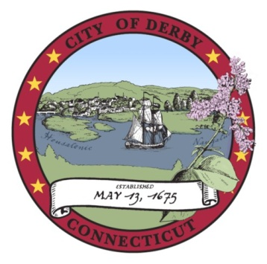
pap

.

CITY OF DERBY BOARD OF EDUCATION
FIELD HOUSE RIBBON CUTTING CEREMONY SUB- COMMITTEE
MEETING AGENDA

Derby Middle School Cafetorium
73 Chatfield Street, Derby, CT 06418
6:00 p.m.
April 22, 2019

 | ITEM | LEADER | TIME
I. | CALL TO ORDER  - Opening Ceremonies  - Roll Call | Mrs. Harris | 6:00 p.m.
II. | PUBLIC PARTICIPATION  * Prior to the commencement of any public meeting of any board of the city, the agenda for said meeting shall be posted in the meeting room and the first order of business of said meeting shall be the entertainment of public discussion on any item on said agenda and the conduct, length, and method of terminating said public discussion shall be determined by majority vote of the members of said board of commission. | Mrs. Harris | 7:03 p.m.
III. | APPROVAL OF MINUTES  Motion: The Field House Ribbon Cutting Sub-Committee approve its minutes of the March 25, 2019 meeting. | Mrs. Harris | 6:08 p.m.
IV. | DISCUSS THE DATES, INVITATION AND PROGRAM FOR THE RIBBON CUTTING CEREMONY | Mrs. Harris  Dr. Conway | 6:10 p.m.
V. | ADJOURN  Motion: The Field House Ribbon Cutting Sub-Committee adjourn its meeting. | Mrs. Harris | 6:30 p.m.

Laura Harris, Chair
Field House Ribbon Cutting Ceremony Subcommittee

