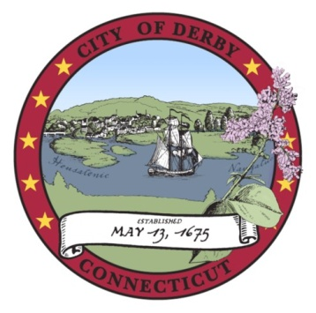
pap

.

CITY OF DERBY BOARD OF EDUCATION
FIELD HOUSE RIBBON CUTTING DEDICATION SUB- COMMITTEE
MEETING AGENDA

Derby City Hall
One Elizabeth Street, Derby, CT 06418
6:00 p.m.
August 12, 2019

 | ITEM | LEADER | TIME
I. | CALL TO ORDER  - Opening Ceremonies  - Roll Call | Mrs. Harris | 6:00 p.m.
II. | PUBLIC PARTICIPATION  * Prior to the commencement of any public meeting of any board of the city, the agenda for said meeting shall be posted in the meeting room and the first order of business of said meeting shall be the entertainment of public discussion on any item on said agenda and the conduct, length, and method of terminating said public discussion shall be determined by majority vote of the members of said board of commission. | Mrs. Harris | 6:03 p.m.
III. | APPROVAL OF MINUTES  Motion: The Field House Ribbon Cutting Sub-Committee approve its minutes of the July 8, 2019 meeting. | Mrs. Harris | 6:08 p.m.
IV. | J. R. PAYDEN FIELD HOUSE PLAQUE | Mrs. Harris | 6:10 p.m.
V. | UPDATE PROGRAM, INVITATION AND INVITEE LIST | Mrs. Harris | 6:20 p.m.
VI. | ADJOURN  Motion: The Field House Ribbon Cutting Sub-Committee adjourn its meeting. | Mrs. Harris | 6:45 p.m.

Laura Harris, Chair
Field House Ribbon Cutting Ceremony Subcommittee

